Lab: Mounting HDFS to a Local File System

|  |  |
| --- | --- |
| **Objective:** | To learn how to mount HDFS to a local file system. |
| **Successful Outcome:** | HDSF will be mounted to /home/hdfs/hdfs-mount. |
| **Before You Begin:** | SSH into node1. |

1. Install NFS
   1. Execute following yum command to install NFS on node1:

# yum -y install nfs*

1. Configure NFS
   1. Within Ambari, stop the HDFS service.
   2. Go to Services -> HDFS -> Configs, scroll down to the Advanced section and click on the Advanced heading to expand the section.
   3. Locate the dfs.namenode.accesstime.precision property and set it to 3600000.
   4. Scroll down to the "**Custom hdfs-site.xml**" section.
   5. Using the "**Add Property...**" link, add the following new properties:

**dfs.nfs3.dump.dir=/tmp/.hdfs-nfs**

**dfs.nfs.exports.allowed.hosts=* rw**

* 1. Scroll down to the "**Custom core-site.xml**" section.
  2. Using the "**Add Property...**" link, add the following new properties:

**hadoop.proxyuser.root.groups=users**

**hadoop.proxyuser.root.hosts=\***

* 1. Click the Save button to save your changes.
  2. Restart all impacted services as pointed on ambari UI.

1. Start NFS
   1. Run the following commands to stop the nfs and rpcbind services. (If they are not running, the following commands will fail, which is no problem):

# service nfs stop

# service rpcbind stop

* 1. Now start the NFS services:

# hdfs portmap &

# hdfs nfs3 &

**NOTE**: If you don’t see your command prompt, simply press Enter.

* 1. Verify that the required services are up and running.

# rpcinfo -p node1

You should se output similar to the following:

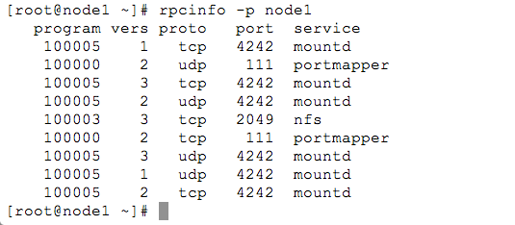

* 1. Verify that the HDFS namespace is exported and can be mounted by any client.

# showmount -e node1

You should se output similar to the following:

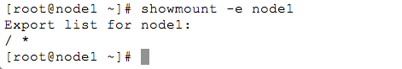

1. Mount HDFS to the Local File System
   1. As the root user, create a new directory on your local file system named /home/hdfs/hdfs-mount.
   2. Change its ownership to the hdfs user.
   3. Execute the following command on a single line to mount HDFS to the hdfs-mount directory:

# mount -t nfs -o vers=3,proto=tcp,nolock

node1:/ /home/hdfs/hdfs-mount

* 1. Browse HDFS now on your local file system.

# ls -l /home/hdfs/hdfs-mount

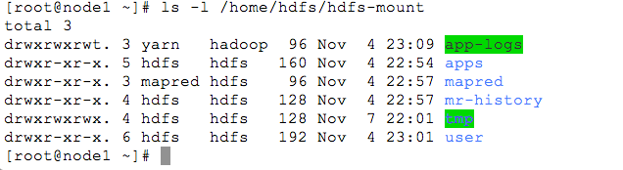

* 1. Switch to the hdfs user.
  2. Copy a local file using the cp command into the hdfs-mount directory, and then check whether you can see this file using the hadoop fs -ls / command.
  3. Delete the file from the local file system using the rm command, and verify the file is no longer in HDFS.
  4. Try other Linux commands and see whether they work successfully.

**RESULT**: You have mounted HDFS to a local file system, which can be a convenient skill to know how to do when working frequently with files in HDFS.